ICS Form 201

INCIDENT BRIEFING |  | 1. Incident Name  Barge 160-1\Quinhagak | 2. Date Prepared  17Sep09 | 3. Time Prepared  1200
4. Map Sketch
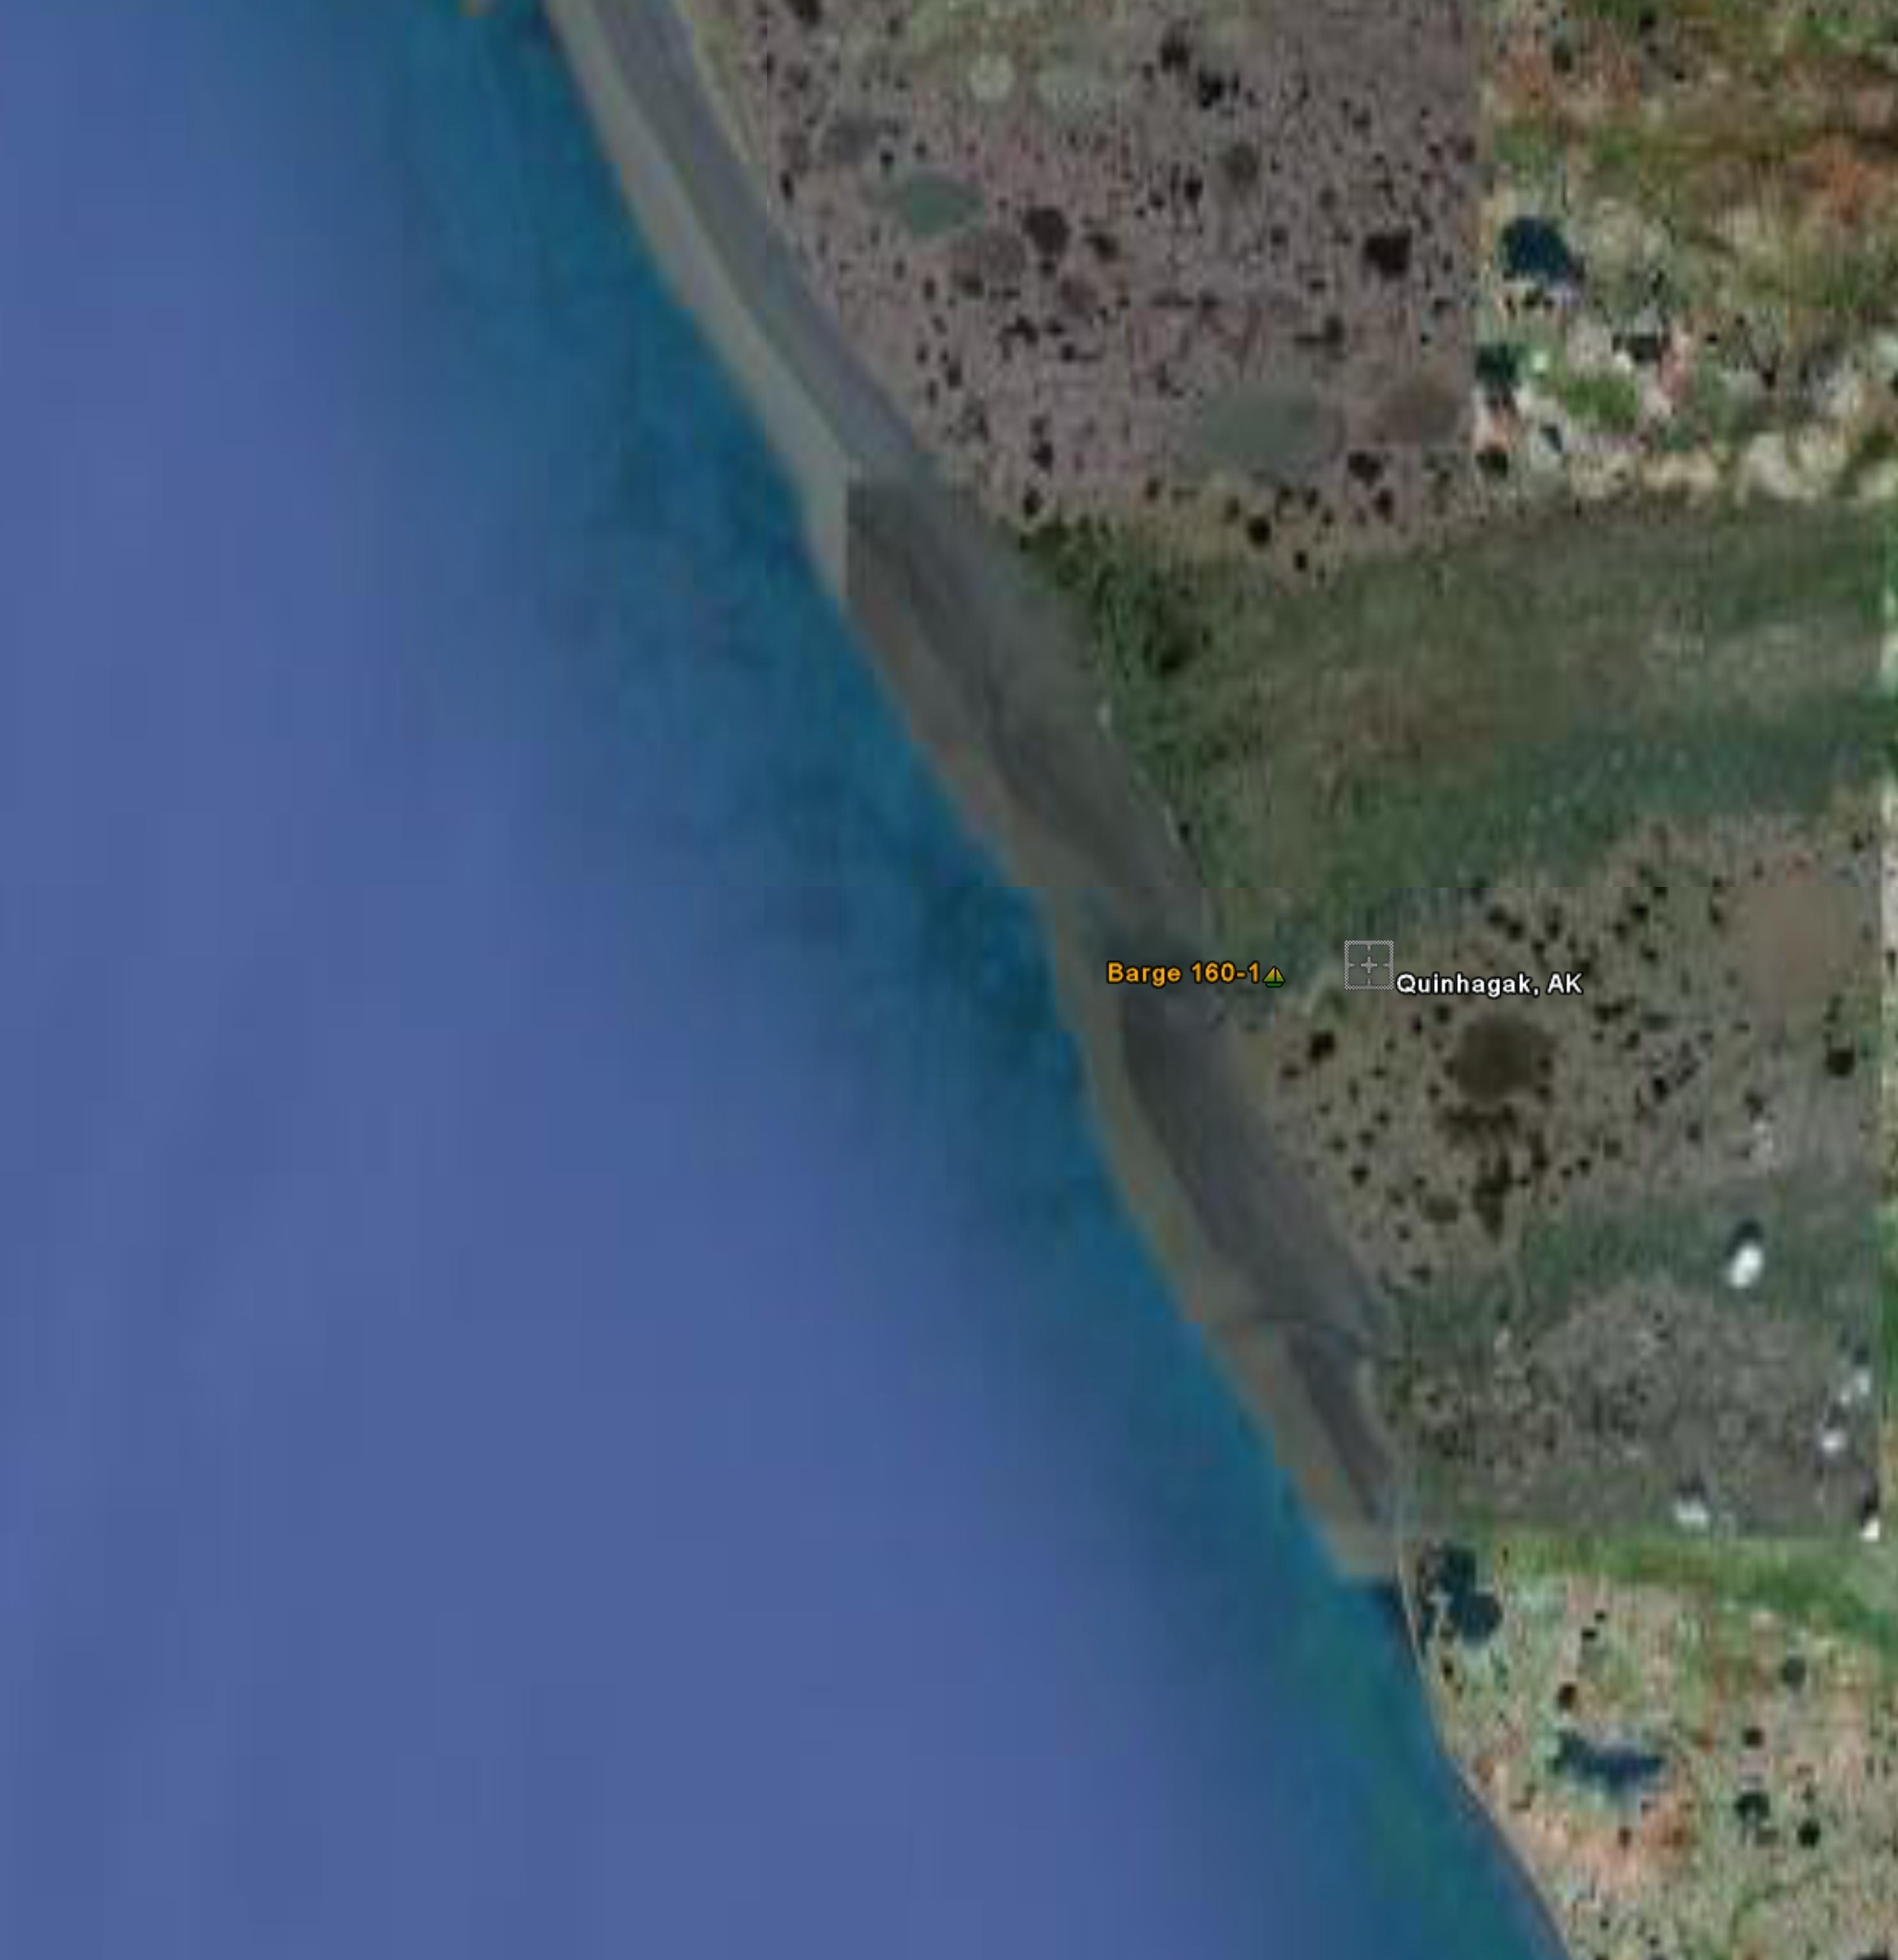
ICS 201  Page 1 of 4 | 5. Prepared by (Name and Position)  MST2 Holle\MST3 McGill

6. Summary of Current Actions
Crowley Barge 160-1 ran aground near Quinhagak, AK at approximately 59 45N, 161 55W. Barge has 57,000 gallons of gasoline, 57,000 gallons of Jet fuel for a total of 114,000 gallons of oil. Barge 160-1 is a 1968 single skin barge.
Barge 160 has currently undergone 2 tide cycles and tug can not pull barge off bottom.

1000 Sector Anchorage notified of Barge 160-1

**Est. 1830 Sector Inspector and Foscr C-130 overflight.
ICS 201 | Page 2

7. Current Organization
ICS 201 | Page 3

8. Resources Summary
Resources Ordered |  | Resource Identification | ETA | On Scene | Location/Assignment
ICS 201 | Page 4

